5 SECONDS QUICK EDITING GUIDE FOR MICROSOFT WORD
Most researches would require that you submit a copy of your findings after your research. The commonest means of doing this is by the use of Microsoft word. This has been in existence for long and the knowledge of its use is expected even before admission into most tertiary institutions. Yet, the submissions from students, and researchers generally, show that they lack this knowledge; are not enforced strictly to comply with guidelines; are just lazy or they do not just edit their work at the end, after all the apparent work. This just screams unprofessionalism and recklessness.

The is a dearth of final editing in even in most final drafts. Negligence evidently, after doing all the 'hard work.'
Presented with the aid of illustrations are quick editing tips for Microsoft word, to make the presentation of your work after the research professional.

1. INCONSISTENT FONT AND SIZE: It is quite amazing when you go through a master's thesis and notice this anomaly as well. The font is responsible for the way the letters appear. There are several font types in available in all versions of Microsoft Word.
For formal use: Times New Roman, Calibri, Verdana, Arial are commonplace. The most preferred being Times New Roman because of the feel of professionalism.
Standard font sizes that are most accepted is 10.5 - 12.5. The best being either font size 11 or 12.
You get to see something like:
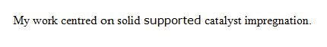
The above illustration would require an effort to notice but what is worth doing, is worth doing well. The 'on' and 'supported' are not in the same front as the rest. A hard copy/print-out would have revealed this better. This is common when the typist copies and pastes directly, without proper checks for fonts consistency.
SOLUTION: Hold down the CONTROL key and press 'A' + select a font type and size to put this all in place.
The font type can be selected at the upper left corner.
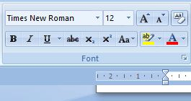

2. UNJUSTIFIED WORK: This is how the edges of each paragraph looks like. This is another very shameful error that could be detected in your work after all the labour.
You get to see submissions taking the format below:
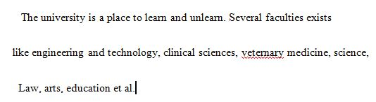
The paragraphing was not consistent, the end edges too. It was just not justified.
SOLUTION: After typing your work, and correcting all possible errors, pressing down the control key and hitting the 'A' selects all therein then pressing the control button again and pressing 'J' corrects this. Another method is to select all (control 'A' or using the mouse to select all), then pressing the justify button to align it as shown below.
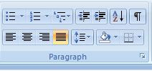
The highlighted is what to click on to make it 'justified.' Giving it that clean look it deserves.

3. INCONSISTENT SPACING: This is another goof. Some parts of the work could be 'single' spaced, some 'double' or even of 'multiple' spacing.
SOLUTION: The text is highlighted, right clicked then the 'spacing' option selected, then the type wanted is chosen.
Shown below:
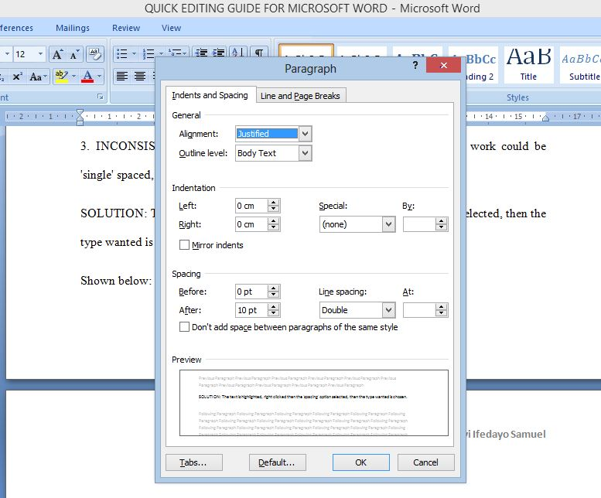
The summary of the 5 seconds editing method. CONTROL 'A', SELECT FONT TYPE AND SIZE. CONTROL 'A', CONTROL 'J'. CONTROL 'A', RIGHT CLICK, SELECT SPACING. Your work will transform into a professional look in 5 second. I don't even want to see poorly edited work again!

<iframe src="https://docs.google.com/forms/d/1H0C7LqA_xg4Qa3C98XxfXSzW3GTdxSP6KK6fTZjmCUc/viewform?embedded=true" width="760" height="500" frameborder="0" marginheight="0" marginwidth="0">Loading...</iframe>

